Hibernating an EC2 Instance

Lab Steps

Task 1: Sign in to AWS Management Console
- Click on the Open Console button, and you will get redirected to AWS Console in a new browser tab.
- On the AWS sign-in page,
- Leave the Account ID as default. Never edit/remove the 12 digit Account ID present in the AWS Console. otherwise, you cannot proceed with the lab.
- Now copy your User Name and Password in the Lab Console to the IAM Username and Password in AWS Console and click on the Sign in button
3. Once Signed In to the AWS Management Console, Make the default AWS Region as US East (N. Virginia) us-east-1.

Task 2: Launching an EC2 Instance
1. Navigate to EC2 by clicking on the Services menu in the top, then click on EC2 in the Compute section.
2. Make sure you are in the US East (N. Virginia) us-east-1 Region.
3. Navigate to Instances on the left panel and click on Launch instances.
4. Enter the Name for the Instance
- Name : Enter WhizInstance
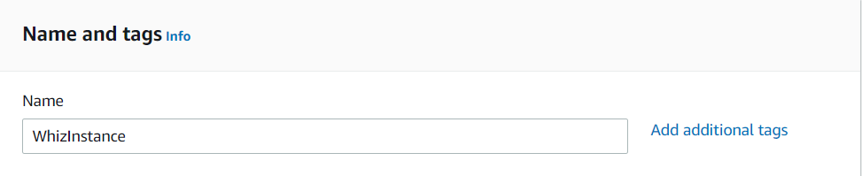
5. Choose an Amazon Machine Image (AMI): Select Amazon Linux 2 AMI in the drop-down.
- Choose architecture as 64-bit(x86)
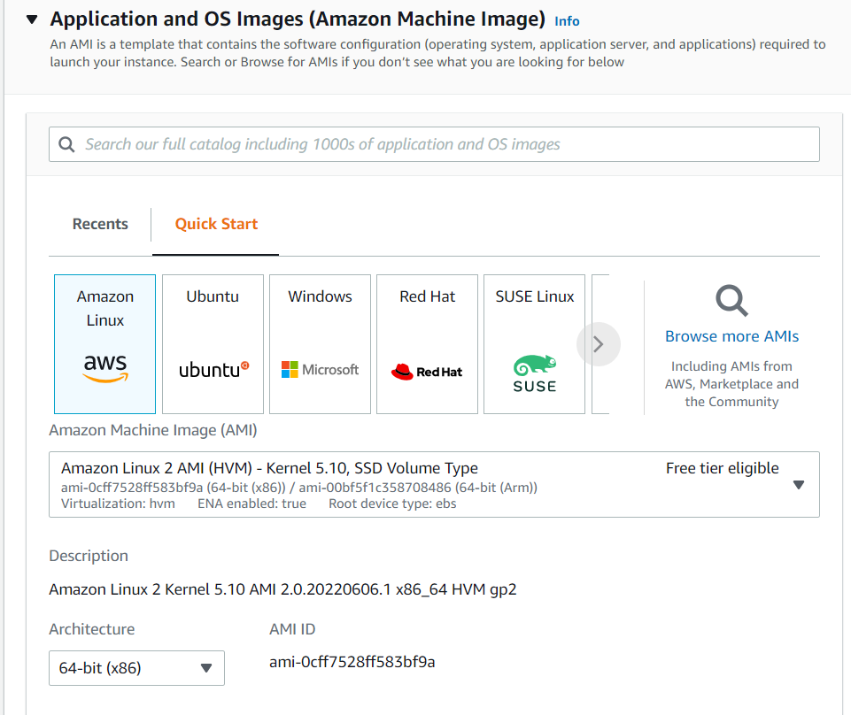
6. Choose an Instance Type: Select t2.micro.
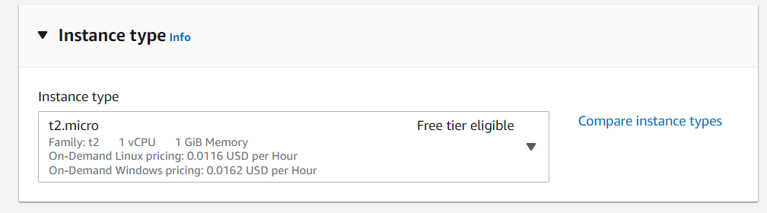
7. Key Pair: Select Create a new key pair
- Key pair type : Select RSA
- Key pair name: Enter MyEC2Key
- Private key file format: Select .pem
- Click on the create Key pair button.
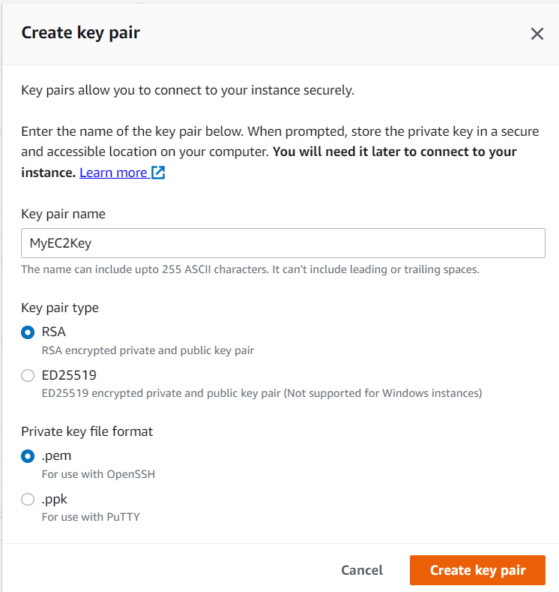
8. Click on the drop-down of the Network Settings.
9. Configure Security Group:
- Select Create security group
- Check the checkbox for SSH
- Choose the My IP option at the right side drop-down.
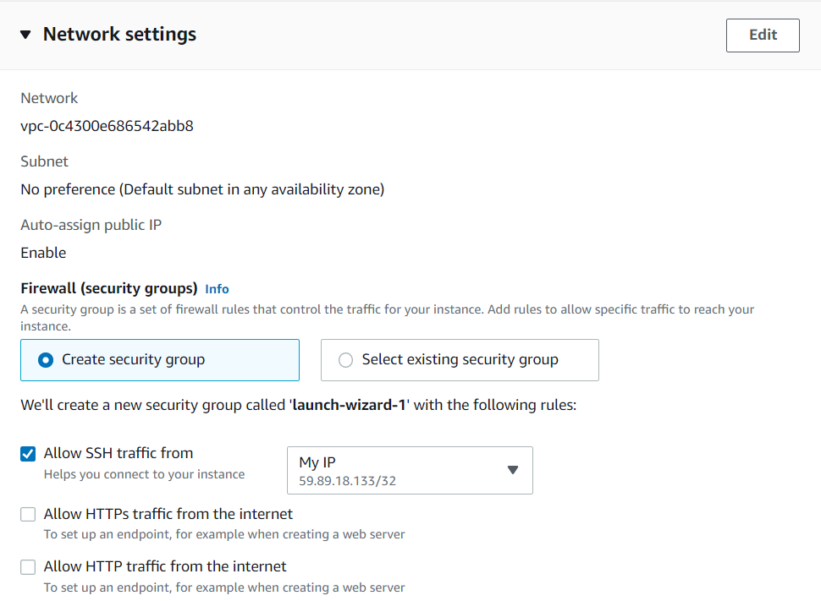
10. Click on the Advanced option at the top right corner of the Configure Storage.
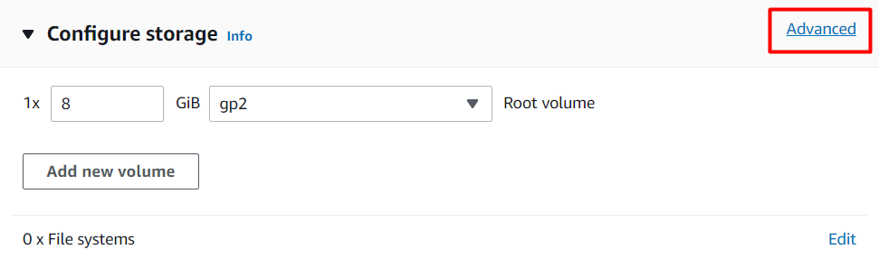
11. Click on Volume 1 (AMI Root).
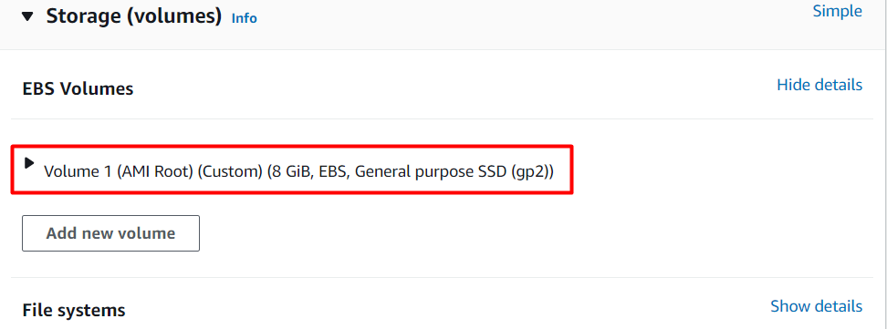
12. Select Yes from the Encrypted drop-down and (default) aws/ebs key from the KMS Key drop-down.
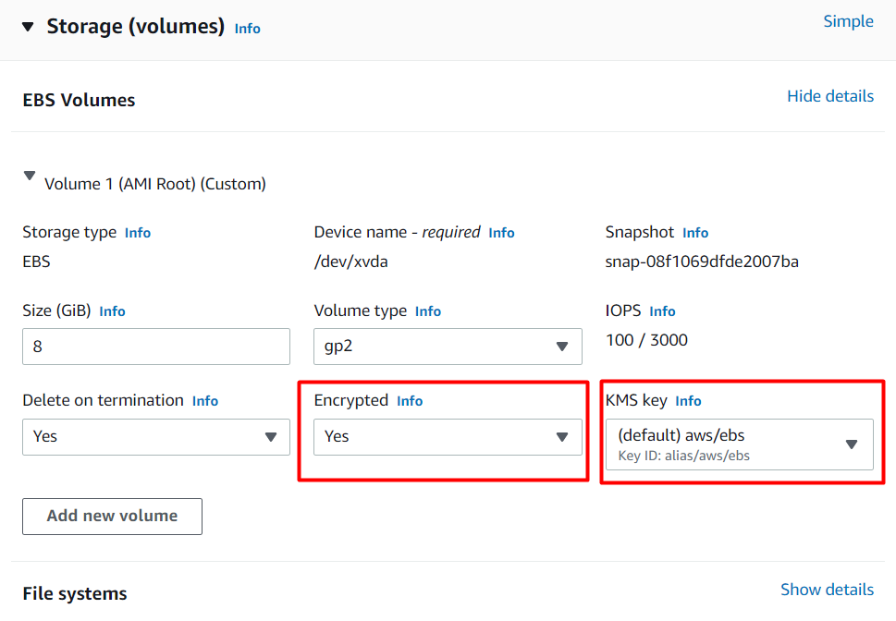
13. Click on the Advanced details button and select Enable from the Stop-Hibernate Behaviour drop-down.
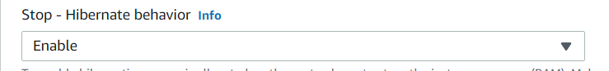
14. Review and Launch: Review all settings and click on Launch Instance at the bottom right.
15. Launch Status: Your instance is now launching, Click on the instance ID and wait for complete initialization of the instance till the status changes to Running.

Task 3: Testing Hibernation of an EC2 Instance
We can test the hibernation of the EC2 either using the Dashboard or using CloudShell.

Method 1:
- Select the instance from the Instances panel and click on Instance State.
- Click on Hibernate Instance.
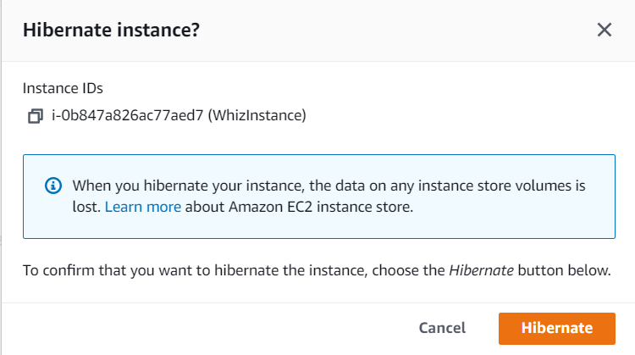
- Select the Hibernate button.
- You can see that the Instance state has been changed from Running to Stopped.
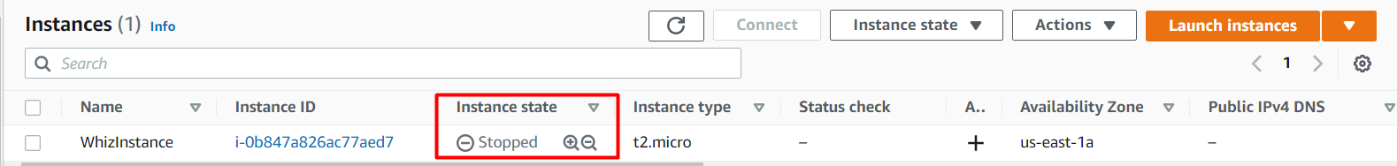
5. Select the Instance again and Select Instance State as Start Instance.
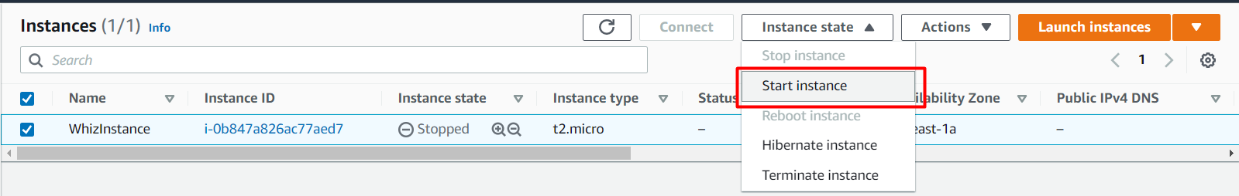
6. We can see that Instance starts running again.

Method 2:
1. Go to EC2 Dashboard and copy the Instance ID of your instance.
2. Go to AWS CloudShell by clicking on  at the top right of the AWS console.
3. We can use the Stop action to hibernate an instance because we have enabled the Stop-Hibernation behavior. To hibernate the instance, run the command:
aws ec2 stop-instances --instance-ids <instance_id>
- Note:- Replace <instance_id> with the Instance ID you have copied in Step 1.
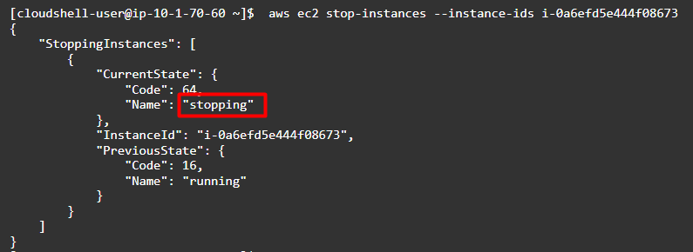
4. Run the following command to start the instance.
aws ec2 start-instances --instance-ids <instance_id>
- Note:- Replace <instance_id> with the Instance ID you have copied in Step 1.
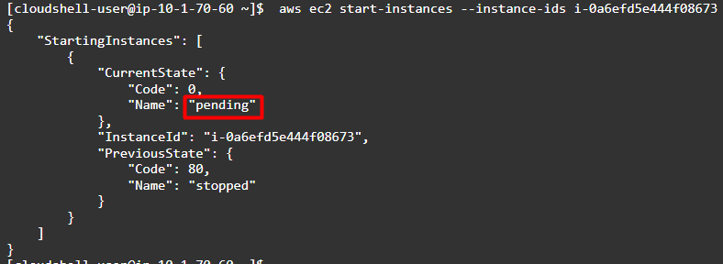
5. Wait for a few minutes and run the command again. You can see that the instance state has changed from pending to running state.
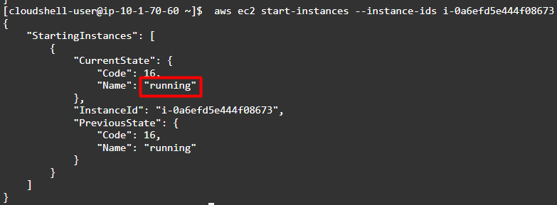

Do you know?
Hibernating an Amazon Elastic Compute Cloud (EC2) instance is a feature provided by AWS that allows you to pause an EC2 instance instead of stopping it. When you stop a traditional EC2 instance, it goes into a stopped state, and you're no longer charged for the instance's compute resources (CPU and memory). However, when you start it again, you need to wait for the instance to boot up, which can take some time, and you may lose any in-memory data or configurations that were stored on the instance.

